**[Bipartite Graph](https://leetcode.com/problems/is-graph-bipartite/description/)**

Given an adjacency list of a graph**adj**of V no. of vertices having 0 based index. Check whether the graph is bipartite or not.

**Example 1:**

**Input:**

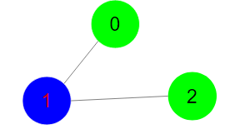

**Output:** 1

**Explanation:** The given graph can be colored

in two colors so, it is a bipartite graph.

**Example 2:**

**Input:**

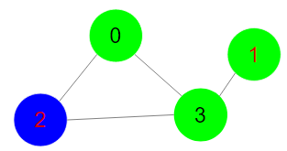

**Output:** 0

**Explanation:** The given graph cannot be colored

in two colors such that color of adjacent

vertices differs.

**Your Task:**  
You don't need to read or print anything. Your task is to complete the function **isBipartite()**which takes V denoting no. of vertices and adj denoting adjacency list of the graph and returns a boolean value true if the graph is bipartite otherwise returns false.

**Expected Time Complexity:**O(V + E)  
**Expected Space Complexity:**O(V)  
  
**Constraints:**  
1 ≤ V, E ≤ 105